1. What I noticed after deploying to elastic bean stalk is, when I click on the link provided, I was taken to the website where the application is hosted.

What I noticed when using Jenkins is that, its really case sensitive and any minor issue will make the test and build be a failure

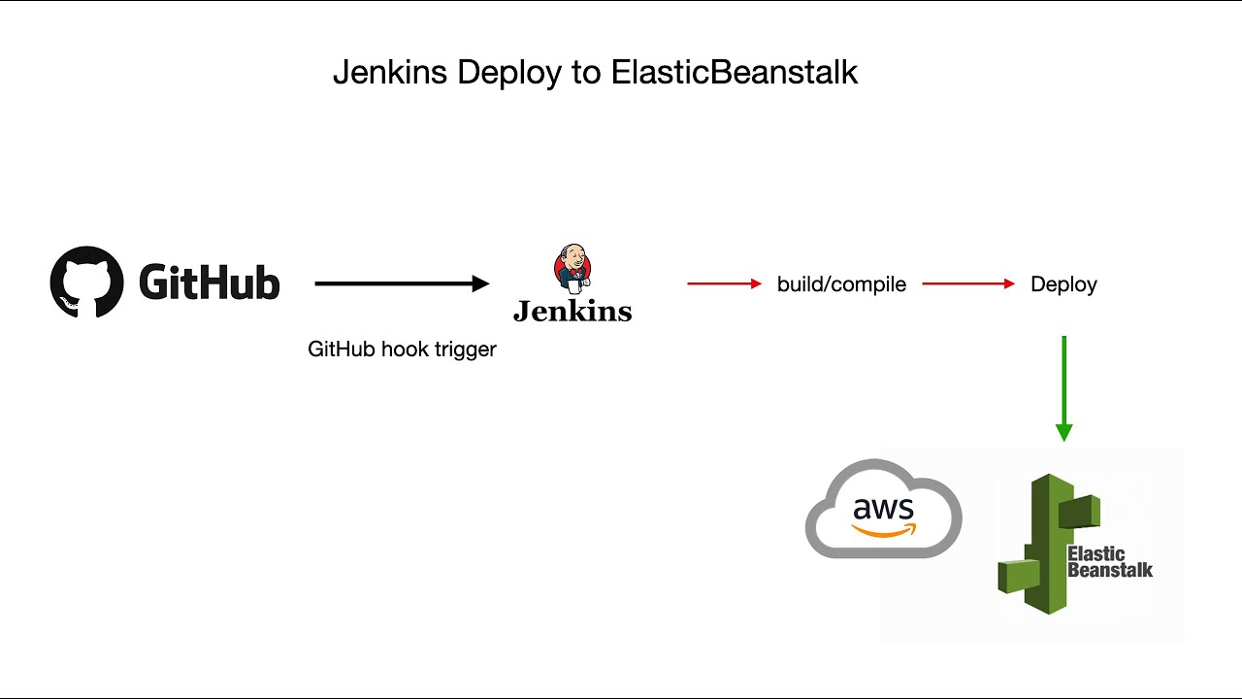

1. What I could’ve improved is writing a scrip to spin up Jenkins and aws ec2 and elasticbean stalk as well because I had to repeat this process over and over.